Experiment: 2
AIM:To implement a Deep Neural Network (DNN) for a classification task using TensorFlow and Keras.
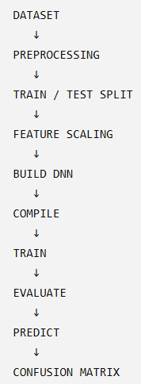 "This is the standard workflow you should remember for almost every basic DNN classification problem."
Algorithm:
- Import the required libraries.
- Load the dataset.
- Split the dataset into training and testing sets.
- Normalize the input features.
- Build a Deep Neural Network with input, hidden, and output layers.
- Compile the model using an optimizer and loss function.
- Train the model.
- Evaluate the model.
- Predict the class labels for test data.
Input features: Suggested dataset: Iris
Sepal Length, Sepal Width, Petal Length, Petal Width(features)
Output label : Setosa / Versicolor / Virginica(classification class)
Implementation:
1] IMPORT LIBRARIES REQUIRED
2] DATASET LOADING
3] DATASET INSPECT: print(X.shape) print(y.shape) print(iris.target_names)
4] DATA SPLIT: test_size=0.2,(20% DATA FOR TESTING) random_state=42
Use the same random sequence every time, There is nothing special about 42, using a fixed integer, not the number 42 itself, 42 is just a seed value. It is not a mathematical constant or a special deep-learning value.
5]BUILD DNN: Dense(16) :16 neurons in hidden layer, activation='relu' Non-linear activation, input_shape=(4,) Four input features,Dense(3) Three output neurons corresponding to: 0 → Setosa 1 → Versicolor 2 → Virginica, softmax Produces
Optimizer | - Updates weights
class probabilities.
6]COMPILE THE MODEL:

Loss | - Measures prediction error

Accuracy | - Measures correct predictions
Loss parameters: sparse_categorical_crossentropy : labels are integer encoded categorical_crossentropy: labels were one-hot encoded
7]TRAIN THE MODEL: Epoch :One complete pass through the training data.
Batch size: Number of samples processed before updating weights.
Validation split: Part of training data used to monitor performance during training.
8]EVALUATE: Validation, overfitting , underfitting
9]PREDICTION
CHALLENGES:
1] CHANGE 16 TO 32 NEURONS IN HIDDEN LAYER: Observe the change in:
Parameters, Training accuracy, Test accuracy
2] CHANGE epoch 50 to 100 Does accuracy always increase?
3] Remove 1 HIDDEN LAYER and Compare with original DNN

